**Assignment -1**

Python Flask

|  |  |
| --- | --- |
| Assignment Date | 13 September 2022 |
| Student Name | Mr. Naveenkumaran R |
| Student Roll Number | 711319CS101 |
| Maximum Marks | 2 Marks |

**Question-1:**

1. Create registration page in html with username, email and phone number and by using POST method display it in next html page?

**Solution:**

**Registration.html**

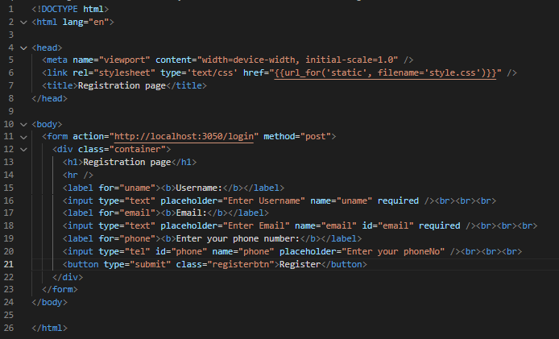

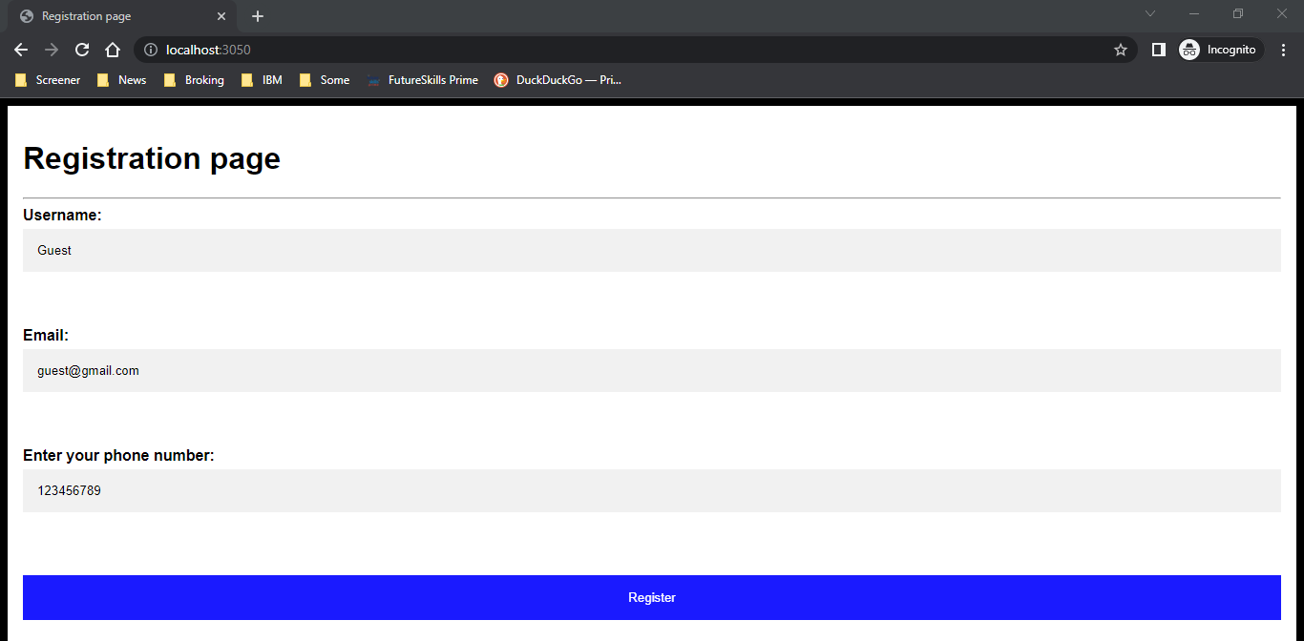

**Display.html**

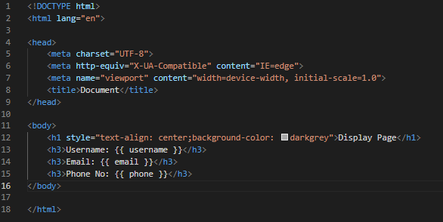

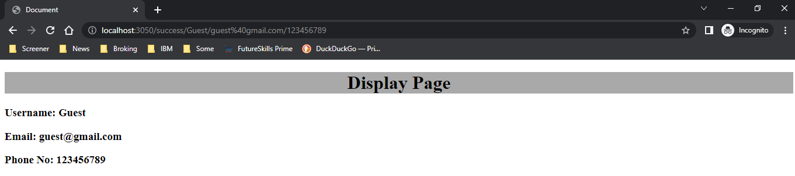

**App.py**

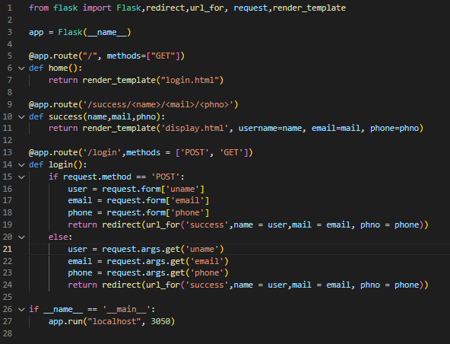

**Question-2:**

1. Develop a flask program which should contain at least 5 packages used from pypi.org ?

**Solution:**

**flaskapp.py**

